Use Case Specification

DMT/RM01/TMP

|  |  |
| --- | --- |
| Project Code | PRJ_RaiseTicket_002 |
| Project Name | Issue Tracking System |

|  |  |  |
| --- | --- | --- |
| Prepared/Modified by | Role | Date of Preparation |
| Apurv Agrawal | Analyst | 20th December, 2017 |
| Reviewed by | Role | Date of Review |
| Manish Nagle | Analyst | 22nd December, 2017 |
| Approved by | Role | Date of Approval |
| Dayanand Patil | Consultant | 24th December, 2017 |
| Circulation List |  | Version Number of the template:1.1 |
| Version Number | 1.1 |  |

<<Customer>> REVIEW HISTORY

<<Customer comments on the Use case along with the signed off is tracked here>>

|  |  |  |  |  |  |  |
| --- | --- | --- | --- | --- | --- | --- |
| Version | <<Version number>> |  |  |  |  |  |
| Date | <<Date of Review>> |  |  |  |  |  |
| Reviewed by | << Reviewer Name>> |  |  |  |  |  |
| Reviewed UI Specification doc | << Whether UI Specification doc is reviewed >> |  |  |  |  |  |
| All Open Queries/issues closed | << Whether all the open queries and issues resolved>> |  |  |  |  |  |
| Agreement on Assumptions | <<Whether all the assumptions have been agreed upon by the customer>> |  |  |  |  |  |
| Sign Off | <<Signature>> |  |  |  |  |  |

Disclaimer:

The scope of the project ‘FlyWithMe Airline System’ is restricted to the contents of this signed off use case.

TABLE OF CONTENTS

Use Case Name: Raise Ticket in the Issue Tracking System 5

Actor(s) 5

Preconditions 5

Flow of Events 5

4.1 Basic FloW: Successful Raise of Ticket 5

Alternative Flows 6

4.2.1 Alternate Flow 1: Successful Raise of Ticket when login to the system in Second Attempt 6

4.2.2 Alternate Flow 2: Successful Raise of Ticket when filling the correct data in all the field fields marked as (*) 6

4.2.3 Alternate Flow 3: Successful Raise of Ticket when behalf of other employee 6

Exception Flows 7

Exception Flow 1: Login Attempts Get Exceeded. 7

Exception Flow 2: Web Server Down Error 7

Exception Flow 3: Database Connectivity Error 7

Exception Flow 4: Network Connectivity Error 7

Post Conditions 8

Special Requirements 8

Performance 8

Availability 8

User Interface 8

Security 8

Extension Points 9

Extension in Alternate Flow 1: 9

Business Rules 9

Diagrams 9

Use Case Diagram 9

Activity Diagram 10

Scenarios 10

Success Scenarios 10

Failure Scenarios 10

Issues 10

UI Specifications 10

Inter System Dependencies 10

Integration with an already existing System of the <<Customer>> 10

Assumptions 11

Use Case Name: raise ticket in issue Issue Tracking System

**Use Case ID:**  RTITS.EMP.RAISETICKET.UC002

**Brief Description:** The Use Case describes the process by which the employee can raise a ticket In Issue Issue Tracking System using the valid link given in home page

Actor(s)

Employee

Preconditions

1. Employee is being already registered with Issue Issue Tracking System’s website.
2. Customer is having valid User Name and Password to login in the system.
3. Customer is already logged into the Issue Issue Tracking System’s website.
4. IT Infrastructure Management function is within scope of the employee.

Flow of Events

4.1 Basic FloW: Successful Raise of Ticket

1. Employee opens the URL <http://its.servicedesk.com> from the Mozilla Firefox.
2. The Issue Tracking System displays **Login** page
3. Employee Enters a valid domain **Username**
4. Employee Enters a valid **Password**
5. Employee Click on the **Login** button
6. The system validates **Username** & **Password**
7. The system navigates employee to the **Home Page**
8. Employee Click on the ‘Raise New Ticket’ option given on the home page and the form will get displayed.
9. Employee selects the valid function name applicable to him.
10. Employee selects category,subcategory and priority and Enters a subject.
11. Employee Enters a a description and a valid file get attached as a proof.
12. Employee selects proper valid location and extension number.
13. Employee selects the Project Name and Enters a the email id.
14. Employee Click on submit button.
15. System generate a valid RaiseTicketID.

Alternative Flows

4.2.1 Alternate Flow 1: Successful Raise of Ticket by login to the system in Second Attempt

1. Employee open the URL <http://its.servicedesk.com> from the Mozilla Firefox.
2. The Issue Tracking System displays **Login** page
3. Employee Enters a invalid **Username**
4. Employee Enters a **Password**
5. Employee Click on the **Login** button
6. The system validation fails due to invalid employee credentials.
7. The system prompts the employee to re-Enters the username and password
8. The step 6 of Basic flow is followed.

4.2.2 Alternate Flow 2: Successful Raise of Ticket by filling the correct data in all the field fields marked as (*)

1. Employee opens the URL <http://its.servicedesk.com> from the Mozilla Firefox.
2. The Issue Tracking System displays **Login** page
3. Employee Enters a valid domain **Username**
4. Employee Enters a valid **Password**
5. Employee Click on the **Login** button
6. The system validates **Username** & **Password**
7. The system navigates employee to the **Home Page**
8. Employee Click on ‘Raise New Ticket’ option given on the home page and the form will be displayed.
9. Employee selects the valid function name applicable to him.
10. Employee selects category,subcategory and priority and Enters a subject
11. Employee forgoets to Enters a the description and Click on submit button
12. System Prompts the user to Enters all the marked fields.
13. Employee Enters a the mandatory fields.
14. Employee Click on submit button.
15. System generates a valid RaiseTicketID.

4.2.3 Alternate Flow 3: Successful Raise of Ticket on behalf of other employee

1. Employee opens the URL <http://its.servicedesk.com> from the Mozilla Firefox.
2. The Issue Tracking System displays **Login** page
3. Employee Enters a valid domain **Username**
4. Employee Enters a valid **Password**
5. Employee Click on the **Login** button
6. The system validates **Username** & **Password**
7. The system navigates employee to the **Home Page**
8. Employee Click on ‘Raise New Ticket’ option on the home page and the form will be displayed.
9. Employee selects the valid function name applicable to him/her.
10. Employee selects category,subcategory and priority and Enters a a subject
11. Employee Enters a the description and a valid file is attached as proof.
12. Employee Enters a other employee’s id in the field ‘On Behalf’ of himself.
13. The step 12 of Basic Flow is get followed

Exception Flows

Exception Flow 1: Login Attempts Exceeded.

1. Employee opens the URL <http://its.servicedesk.com> from the Mozilla Firefox.
2. The Issue Tracking System displays **Login** page
3. Employee Enters a valid domain **Username**
4. Employee Enters a valid **Password**
5. Employee Click on the **Login** button
6. The system validates **Username** & **Password** for the 4th time.
7. The system validation get fails due to invalid user credentials and no more login attempts are remaining
8. The system has temporarily blocked the employee account
9. The system informs the user that his/her account has been temporarily blocked.

Exception Flow 2: Web Server Down

1. Employee opens the URL <http://its.servicedesk.com> from the Mozilla Firefox.
2. The system displays the error message regarding web server unavailability problem

Exception Flow 3: Database Connectivity Error

1. Employee opens the URL <http://its.servicedesk.com> from the Mozilla Firefox
2. The system displays **Login** page.
3. Employee Enters a **Username**
4. Employee Enters a **Password**
5. User Click on the **Login** button
6. The system validates **Username** & **Password**
7. The system displays an error message regarding database connectivity problem.

Exception Flow 4: Network Connectivity Error

* 1. Employee opens the URL <http://its.servicedesk.com> from the Mozilla Firefox
  2. The system displays **Login** page.
  3. Employee Enters a **Username**
  4. Employee Enters a **Password**
  5. User Click on the **Login** button
  6. The system validates **Username** & **Password**

7. The system displays an error message regarding network connectivity problem.

Post Conditions

| Flow Name | Post Condition |
| --- | --- |
| Successful login to Issue Tracking System on the first attempt AND employee has Successfully Raised a ticket | User will be logged in to the system successfully and system should navigate user to the home page where the option raise a ticket is available |
| Successful login to Issue Tracking System on the second attempt AND USER has Successfully raise a ticket | User will be logged in to the system successfully and system should navigate user to home page where the option raise a ticket is available |
| Exceeded Login Attempts | The system should suspend user account and should inform the user that his/her account has been blocked. |
| Web Server Down | The system should display an error message to the user regarding problem of web server unavailability. |
| Database Connectivity Error | The system should display an error message to the user regarding problem related to database connectivity |
| Network Connectivity Error | The system should display an error message to the user regarding problem related to the network connectivity. |
| User leaves the any column blank and click on submit | The System Prompts the user that he should enters all the marked fields(*) |

Special Requirements

Performance

1. The system should generate the Raise Ticket ID within 5 seconds of submission of the form.

Availability

1. The employee should be able to raise a ticket anytime when he/she is facing problems.

User Interface

1. The Labels of the form should be bold
2. All the by drop down menus should have default option
3. Mandatory fields should be marked by astricks(*)
4. The logout and back button should be available on every page.

Security

1. Remember the credential option should save username and password in the html cookies.
2. The Issue Tracking System will allow employees to Cancel the raised ticket at any time

Extension Points

Extension in Alternate Flow 1:

In step 3, if the employee has entrs wrong user credential than,

1.The system prompts the employee to re-enters the credentials

2. Employee Enters the username and password

3. Step 5 of basic flow is get followed

<<Use extension points to specify the point of an extended use case where an extending use case's behaviour should be inserted>>

Business Rules

| Business Rule Name | Business Rule Description | System action (if BR fails) |
| --- | --- | --- |
| BR01 | Fields marked with the asterisk(*) is mandatory fields | The system should displays an error message if the marked fields are left blank |
| BR02 | Extension number should be max of 4 digits | The system should displays an error message “Extension number is Incorrect” |
| BR03 | The application only accepts files with format :- (.gif,.jpg,.doc) | The system displays message “Format of file selected is invalid” |

Diagrams

Use Case Diagram

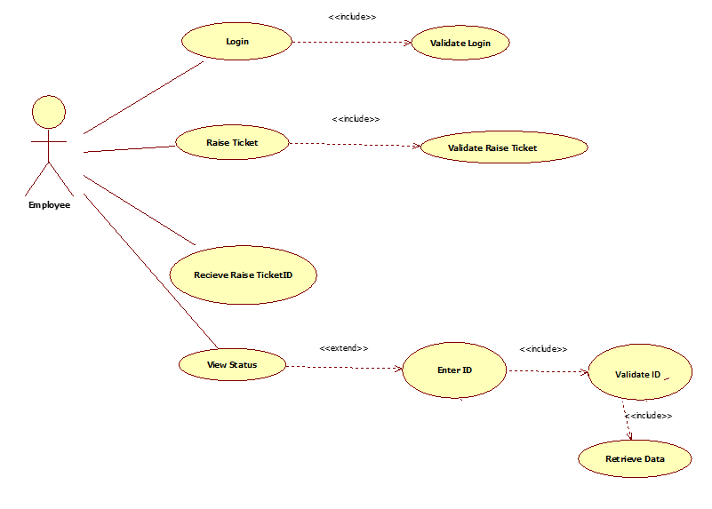

Activity Diagram

<< Activity Diagram gives the high level interaction between the user, system and sub systems. Ideally only one activity diagram should be made per use case. >>

Scenarios

Success Scenarios

* Basic Flow

1. Successful raising of the ticket

* Alternate Flow

1. Successful raising of ticket by login in second attempt
2. Successful raising of ticket by filling all the fields correctly in second attempt.
3. Successful raising of ticket using other employee’s id.

Failure Scenarios

* Exception Flow

1. Failed to raise the ticket because of the exceeded login attempts.
2. Failed to raise the ticket due to the web server issues.
3. Failed to raise the ticket due to database connectivity problem
4. Failed to raise the ticket Because of network connectivity issue

Issues

UI Specifications

<< Provide a link to the UI specification document of the Use case. Please don’t embed the document here>>

Inter System Dependencies

<<Mention the related functionality within the application that is impacted because of this use case. E.g variable or value settings in this use-case which will have a direct impact on the functionality of another use-case. Or vice-versa.>>

**Module:** <<Specify the Module, which will be impacted due to this use case>>

Use case name: <<Use case Name>>

**Impact**: <<Mention the impact on the above mentioned Use case due to this use case>>

Integration with an already existing System of the <<Customer>>

<< This thing is especially applicable if the project at the hand is an enhancement to an existing system.>>

**Module:** <<Specify the Module, which will get impacted due to this use case>>

**Entity:** <<List down the entities, which could be impacted because of this use case>>

**Information: <<**Mention the Impact in brief. >>

Assumptions

1. The Issue Tracking System application is up & running.
2. The Employee should have the latest version of browser for the best view of site
3. There should be a stable internet connectivity to get smooth execution of process

REVISION HISTORY OF THE WORK PRODUCT

<to be maintained by projects>

|  |  |  |  |  |  |
| --- | --- | --- | --- | --- | --- |
| # | Date | Version # | Section Changed | Details of changes made | Approved By |
| 1 |  |  |  |  |  |
| 2 |  |  |  |  |  |